BARBEQUED MUSHROOMS WITH HERBED CHEESE( Serves 6-8)
Cooking time- 20 Mins Max
INGRIDIENTS
- 12-14 white mushrooms , stems removed and washed
- 2tbsp olive oil
- 2tbsp breadcrumbs
- 3tbsp toasted and chopped walnuts or pine nuts
FOR HERBED CHEESE
- 200gm cream cheese, softened
- 2 cloves garlic,freshly crushed with a little salt
- 1tbsp freshly chopped mixed herbs
- 75gm butter, melted and cooled
FOR FRESH HERBS
- Basil
- Marjoram
- Oregano 3-4 leaves
- Rosemary
- Sage
- Thyme

METHODS
- For the mushrooms ,clean the mushroom caps from inside and remove the black inside particles .
- Brush them with olive oil, sprinkle some breadcrumbs and place them under the grill for 10-12 minutes or until soft till firm to hold.
- Remove and set aside.
HERBED CHEESE

- For herbed cheese ,in a bowl beat cream cheese with the crushed garlic and the fresh chopped herbs, and the gently mix the cooled melted butter intothe mixture. WARNING: DO NOT ADD THE BUTTER WHILE HOT OR ELSE THE MIXTURE WILL CURDLE.
- Take a spoon or a piping bag and stuff the grilled mushrooms with this mixture.
- Sprinkle with nuts, herbs if serving cold.
If serving hot then, sprinkle the mushrooms with mozzarella cheese.
(Its preferable to serve hot for a better cheesy taste)
TO SERVE HOT
- fill the mushrooms with the herbed cheese batter.
- Oven it for 5-10 minutes at a normal temperature.
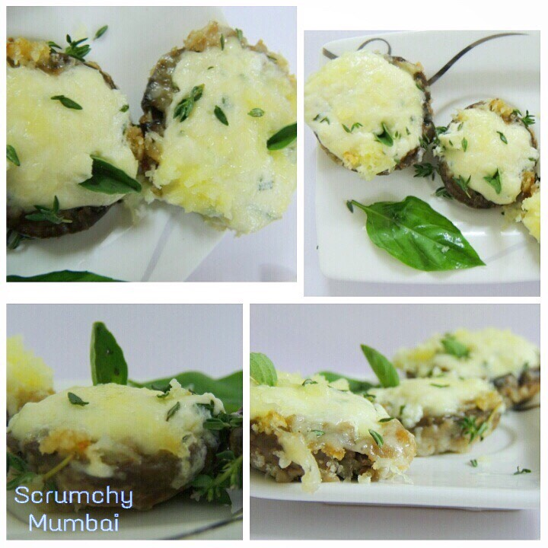
- And garnish it with the left over herbs.

